PE Funding

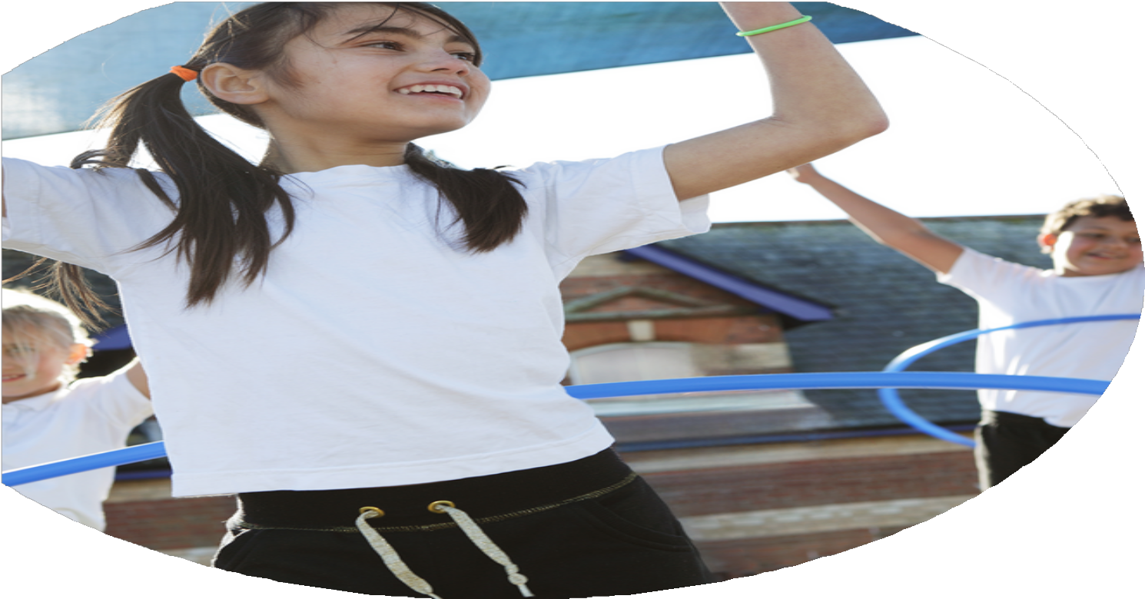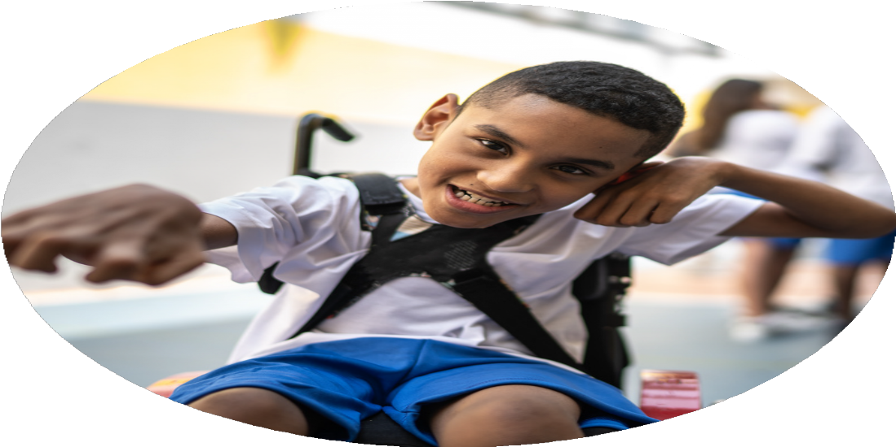

Evaluation Form

**Commissioned by**

**Created by**

Images courtesy of Youth Sport Trust

**PE Funding Evaluation Form**

 It is intended that this template should be used as preparation for the completion of the statutory digital reporting tool being introduced this academic year. You can upload data (including swimming) from this template onto this platform once it becomes accessible.

 Before you decide how you are going to use the funding for this academic year you should reflect and evaluate the impact of your use of the funding in 2023/24.

 All spending of the funding must conform with the terms outlined in the Conditions of Grant document.  The template is a working document that you can amend/update during the year.

 Based on your evaluation of last year’s funding you should decide what you intend to do this academic year, how you will do it, and what impact you expect it to have.

It is important that the funding is used effectively and based on your school’s needs.

 You must use the funding to make additional and sustainable improvements to the PE and sport in your school.  You must develop and add to the PESSPA activities that your school already offers.

*Summative digital reporting from June 2025 will continue to include swimming and water safety information therefore funding can be used to provide top-up lessons where necessary to ensure pupils meet national curriculum swimming requirements.*

**Review of last year 2023/24**

|  |  |  |  |
| --- | --- | --- | --- |
| **What went well?** | **How do you know?** | **What did not go well?** | **How do you know?** |
| **Increased knowledge and confidence of all staff, leading to high-quality curriculum PE lessons.** | PE CPD for 4 teachers through 2 x Curriculum Support Programmes   * 100% of staff reported an increase in confidence teaching PE following the Curriculum Support Programmes. | **To increase physical activity levels to ensure children are meeting the active 30 minutes within school.**  While EYFS and KS1 provision was very strong, provision and engagement of KS2 children in structured physical activity needs to improve in 2024/25. | **Lunchtime Activities:**  % of pupil engaged in structured activity at lunch times:   * EYFS = 66% * Key Stage 1 = 100% * Key Stage 2 = 37%   *(Taken as an average across half-termly observations)* |
| **To support the development of physical literacy within children.**  **To use physical activity to support mental wellbeing.** | Our Personal Best Programme had three target groups:   * - A gross-motor skills group for children in Year 3 and 4 * - A ‘Girls Active’ group for girls in Year 5 and 6 (these were targeted based on both social needs and also gross motor competence). * - A ‘social skills’ group to support children in engagement within curriculum PE lessons.   Personal Best Impact Report: [Read our Impact Report here.](https://sway.cloud.microsoft/bJObB3vTFPMCzFdD?ref=Link) | **To increase physical activity levels to ensure children are meeting the active 30 minutes within school.**  Club attendance was mixed across the school. While some target groups (KS2) did improve on attendance from 2022/23, other groups fell.  Target for 2024/25 is to engage more children from EYFS and KS1 with extra-curricular sport. | *Extra-Curricular Clubs:*   * Total clubs ran across the year: 18 * 53% of children across the whole school * 59% of KS2 * 42% of KS1 * 27% of EYFS   *Compared to 22/23:*   * Total clubs ran across the year: 15 * 51% of children attending at least one club (whole school) * 64% of children from KS1 * 52% % of children from KS2 |

|  |  |  |
| --- | --- | --- |
| **What are your plans for 2024/25?**  **Intent** | **How are you going to action and achieve these plans?**  **Implementation** | **Costings for each intent/ action** |
| **Increased knowledge and confidence of all staff, leading to high-quality curriculum PE lessons.** | * PE CPD for 2 teachers through 1 x Curriculum Support Programmes * Total PE+ Subscription * Subject Leader Support Programme * PE Subject Leadership purchased through Edsential. A. Barnes to act as PE Subject Leader for our school (due to low staff numbers). | 1 x included as part of Premium SLA (£1,150)  Included as part of Premium SLA (£350)  Included as part of Premium SLA (£910)  £5,850  **£8,260** |
| **To increase physical activity levels to ensure children are meeting the active 30 minutes within school.** | * Extra-curricular clubs delivered each half term through Edsential. These will be tailored to target different groups of children across the year and ensure we are offering a broad range of extra-curricular activities for children to access. * Dance afterschool club running all year. * Edsential PlayMaker Award – Training for up to 15 children from Year 5/6 to lead activities for EYFS and Key Stage 1 at lunchtimes. | 3 x afterschool clubs included as part of Premium SLA (3 x £395) + 2 x additional afterschool club through Edsential (£395)  Dance Club running all year (£1,365)  Included as part of Premium SLA (£930)  **£4,270** |
| **To use physical activity to support mental wellbeing.** | * Edsential Personal Best Programme (1 x 6-week programmes delivered throughout the year to target different year groups / children) * Edsential Rainbow Programme (2 x 6-week programmes delivered throughout the year to target different year groups / children) | 1 x included as part of Premium SLA from 23-24 *(No cost as carried over from 2023-24)*  2 x included as part of Premium SLA (£1,150)  **£2,300** |
| **To use school sport to develop social skills and promote physical activity outside of school.** | * Competitions and Events, including Edsential Competitions for All Programme * Access to Wirral School Games competitions and events | Included as part of Premium SLA (£425)  Wirral School Games – No cost to access.  Sports Day Venue Hire - £353.95  Sports Day Coach Hire – £360  Dance Costume Hire - £160  **£1,299.95** |
| **To promote ‘Healthy Lifestyles’ through PE, sport and physical activity.** | * Edsential Fitness and Nutrition Workshops (x2) | Included as part of Premium SLA (£550)  **£550**  **Total - £16,679.95** |

**Intended actions for 2024/25**

**Expected impact/sustainability and supporting evidence**

|  |  |  |
| --- | --- | --- |
| **Intent / Action** | **What impact/intended impact/sustainability are you expecting?** | **How will you know? What evidence do you have or expect to have?** |
| **Increased knowledge and confidence of all staff, leading to high-quality curriculum PE lessons.**   * PE CPD for 2 teachers through 1 x Curriculum Support Programmes * Total PE+ Subscription * Edsential Subject Leader Support Programme | **Proposed Impact:**   * Primary teachers will be more competent and confident to deliver effective curriculum PE lessons having taken part in 6 x ½ days of PE CPD each (staff audits). * Lesson observations will show pupils receive Quality First Teaching across the whole PE curriculum - supported through our Total PE+ subscription, including making links to wider curriculum and supporting social development. * Curriculum PE assessments will show an increased number of children working at age-related expectations for PE.   **How sustainability will be achieved:**   * CPD will have a lasting impact upon teaching and learning. * Staff will be confident and competent teaching a range of curriculum areas. These in turn can be used to support our school in the future e.g. staff leading extra-curricular clubs. | **How will impact be measured:**   * Staff Voice across the year will show a growing confidence with the teaching of PE. * Edsential Impact Reports for Curriculum Support Programmes. * Pupil Voice to highlight the impact of CPD upon PE lessons. * Curriculum PE attainment data. * Class PE floor books. |
| **To increase physical activity levels to ensure children are meeting the active 30 minutes within school.**   * Extra-curricular clubs delivered each half term. * Edsential PlayMaker Award | **Proposed Impact:**   * More pupils will be meeting their daily physical activity goal (30 minutes within school hours) compared to 2023/24. * More pupils taking part in PE and Sport Activities outside of school hours compared to 2023/24. * Increased number of children participating in breakfast and afterschool clubs.   **How sustainability will be achieved:**   * Children will continue their participation within sports outside of school hours. * Participation within clubs will contribute to children increasing physical competence. * Year 5 Play Leaders will continue again in 2025/25 when they are in Year 6. | **How will impact be measured:**   * Club registers and tracking documents * Class discussions and pupil voice * Curriculum PE assessment data (physical skills) * Edsential Impact Report for PlayMaker Award. |
| **To use physical activity to support mental wellbeing.**   * Edsential Personal Best Programme * Edsential Rainbow Programme | **Proposed Impact:**  Pupils will report an increase in one or more of the key outcomes of the programmes:   * Resilience * Self-esteem * Attitudes towards physical activity * Positive mental wellbeing   **How sustainability will be achieved:**   * Staff will be using the Rainbow Programmes as CPD to support the emotional wellbeing of children throughout the school day. * Personal Best programme outcomes will be transferred into the wider curriculum e.g. pupils showing a developing resilience in a range of curriculum areas, not just PE and sport related. | **How will impact be measured:**   * Edsential Impact Reports for Personal Best and Rainbow Programme. * Staff Voice * Pupil Voice |
| **To use school sport to develop social skills and promote physical activity outside of school.**   * Competitions and Events, including Edsential Competitions for All Programme | **Proposed Impact:**   * Participation within competitive sport will support children to further develop teamwork skills, social and communication skills and supported wellbeing through a sense of ‘togetherness’. * Increased number of children participating regularly within a sports club/ team as a result of our competitions provision across the year. * Children will develop a love of a sport and the confidence to strive to achieve their best- leading onto more areas of school and personal life.   **How sustainability will be achieved:**   * Participation within competitions will lead to an increase in the number of children participating within sports outside of school hours. | **How will impact be measured:**   * Edsential Impact Report for Competitions. * Registers and participation tracking documents. * Pupil Voice |
| **To promote ‘Healthy Lifestyles’ through PE, sport and physical activity.**   * Edsential Fitness and Nutrition Workshops (x2) | **Proposed Impact:**   * Children will develop a deeper understanding of healthy lifestyles, especially around how important the role of sleep is to health and wellbeing. | **How will impact be measured:**   * Pupil Voice |

**Actual impact/sustainability and supporting evidence**

|  |  |  |
| --- | --- | --- |
| **Intent / Action** | **What impact/sustainability have you seen?** | **What evidence do you have?** |
| **Increased knowledge and confidence of all staff, leading to high-quality curriculum PE lessons.**   * PE CPD for 2 teachers through 1 x Curriculum Support Programmes * Total PE+ Subscription * Edsential Subject Leader Support Programme * PE Subject Leadership purchased through Edsential | **Impact:**   * Primary teachers are now more competent and confident to deliver effective curriculum PE lessons having taken part in 6 x ½ days of PE CPD each (staff audits). * Lesson observations show pupils receive Quality First Teaching across the whole PE curriculum - supported through our Total PE+ subscription, including making links to wider curriculum and supporting social development. * PE Subject Leader has received 6 hours of CPD, plus on-going support across the year and access to PE CPD events, including Subject Leader Support Network sessions.   **How sustainability has been achieved:**   * CPD will have a lasting impact upon teaching and learning. Staff will take forward with them the knowledge and skills they have developed this year. * Staff are now more confident and competent teaching a range of curriculum areas. These in turn can be used to support our school in the future e.g. staff leading extra-curricular clubs. | **Evidence:**  **Staff Voice:**   * 100% of staff reported an increase in confidence teaching PE following the Curriculum Support Programmes. * 100% of staff reported an increase in confidence teaching PE through using Total PE+ to support teaching and learning. |
| **To increase physical activity levels to ensure children are meeting the active 30 minutes within school.**   * Extra-curricular clubs delivered each half term. * PlayMaker Award delivered to train 15 children from Year 5/6 to enhance lunch time provision | **Impact:**   * More pupils are meeting their daily physical activity goal (30 minutes within school hours) compared to 2023/24. * There are an increased number of children participating in breakfast and afterschool clubs.   **How sustainability has been achieved:**   * Pupils will take the learning and skills from extra-curricular clubs into curriculum PE lessons. | **Evidence:**  *Extra-Curricular Clubs:*   * Total number of clubs ran across the year: 19 * 77% of children across the whole school * 84% of KS2 * 67% of KS1 * 32% of EYFS   *Compared to 23/24:*   * Total number of clubs ran across the year: 18 * 53% of children across the whole school * 59% of KS2 * 42% of KS1 * 27% of EYFS   *Lunchtime Activities:*  % of pupil engaged in structured activity at lunch times:   * EYFS = 25% * Key Stage 1 = 86% * Key Stage 2 = 74%   *(Taken as an average across half-termly observations)*  Edsential PlayMaker Award Programme Impact:   * View our Impact Report here. *(Link to go here)* |
| **To use physical activity to support mental wellbeing.**   * Edsential Personal Best Programme * Edsential Rainbow Programme | **Impact:**  Pupils reported an increase in one or more of the key outcomes of the programmes:   * Resilience * Self-esteem * Attitudes towards physical activity * Positive mental wellbeing   You can see full details of this within the evidence section.  **How sustainability has been achieved:**   * Children will be able to take the skills and strategies learned and apply them into the wider curriculum. * Children will be more confident to take part in further PE and sport activities, which in turn will lead to greater progress. | **Evidence:**  Personal Best Programme:   * [Read our Impact Report here.](https://sway.cloud.microsoft/GSbGwrTRLLHMDtAk?ref=Link&loc=mysways)   Rainbow Programme:   * [Read our Impact Report here.](https://sway.cloud.microsoft/PBjq19A9SLQOiE33?ref=Link&loc=mysways) |
| **To use school sport to develop social skills and promote physical activity outside of school.**   * Competitions and Events, including Edsential Competitions for All Programme | **Impact:**   * Participation within competitive sport has supported children to further develop teamwork skills, social and communication skills and supported wellbeing through a sense of ‘togetherness’. * Increased number of children participating regularly within a sports club/ team as a result of our competitions provision across the year. * Children have developed a love of a sport and the confidence to strive to achieve their best- leading onto more areas of school and personal life.   **How sustainability has been achieved:**   * Children will be able to take the skills and strategies learned into the wider curriculum. | **Evidence:**  Number of sporting events entered:   * 2024 – 25 - 11 * 2023 – 24 - 14 * 2022 – 23 - 10 * 2021 – 22 - 8 * 2020 - 21 – 3   % of children who took part in a sporting competition or event during 2024-25:   * EYFS – 0% * KS1 – 95% * KS2 – 61%   Compared to 2023/24:   * EYFS – 0% * KS1 – 100% * KS2 – 73%   \**All children (F2 – Year 6) did take part in Sports Day held at The Oval as a way to increase the significance of the event, and also to build a pathway into competitive athletics for them.* |
| **To promote ‘Healthy Lifestyles’ through PE, sport and physical activity.**   * Edsential Fitness and Nutrition Workshops (x2) | **Impact:**   * Children have shown a deeper understanding of healthy lifestyles, especially around how important the role of sleep is to health and wellbeing. | **Evidence:**  Pupil Voice following the Fitness and Nutrition workshops:   * 98% of children ‘enjoyed the session’ * 93% of children felt ‘they had a better understanding of how important sleep is to their health’ after taking part. |

*Meeting National Curriculum requirements for swimming and water safety.*

*Priority should always be given to ensuring that pupils can perform safe self-rescue even if they do not fully meet the first two requirements of the National Curriculum programme of study*

|  |  |  |
| --- | --- | --- |
| **Question** | **Stats:** | **Further context - Relative to local challenges** |
| What percentage of your current Year 6 cohort can swim competently, confidently and proficiently over a distance of at least 25 metres? | 73% |  |
| What percentage of your current Year 6 cohort can use a range of strokes effectively [for example, front crawl, backstroke, and breaststroke]? | 67% |  |
| What percentage of your current Year 6 cohort are able to perform safe self-rescue in different water-based situations? | 67% |  |
| **% of Year 6 children meeting National Curriculum requirements.** | **67%** |  |
| If your schools swimming data is below national expectation, you can choose to use the Primary PE and sport premium to provide additional top-up sessions for those pupils that did not meet National Curriculum  requirements after the completion of core lessons. Have you done this? | No |  |
| Have you provided CPD to improve the knowledge and confidence of staff to be able to teach swimming and water safety? | No |  |