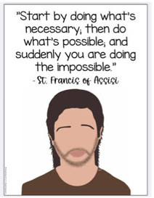
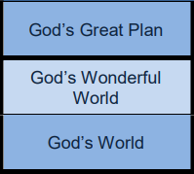
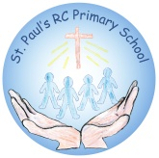
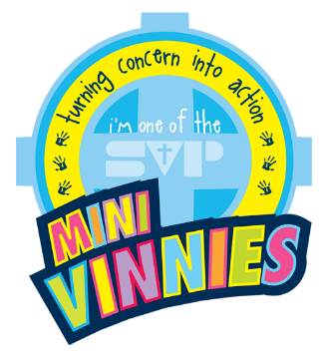
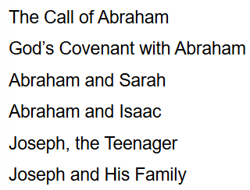




Y5&6
Y3&4
F2
F1
PS2
RE & Catholic Life Newsletter
Autumn 1st Half Term 2025-2026
HARVEST
Wirral Food Bank
MISSION
‘Together in Faith, Working as One’

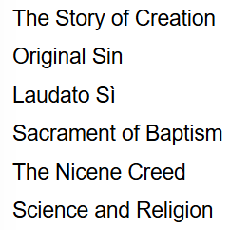
Y1&2

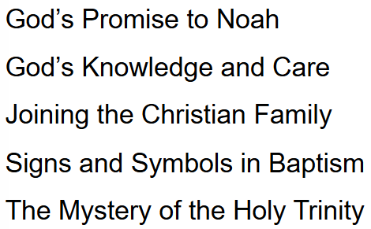

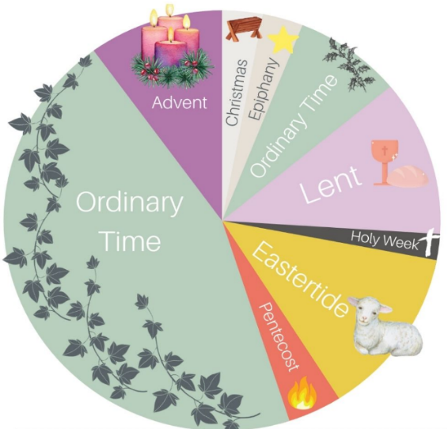
5/9/25 St Teresa of Calcutta
8/9/25 The Birthday of Blessed Virgin Mary
12/9/25 The Most Holy Name of Mary
14/9/25 The Exaltation of the Holy Cross
24/9/25 Our Lady of Walsingham
4/10/25 St Francis of Assisi
7/10/25 Our Lady of the Rosary
18/10/25 St Luke The Evangelist


St Paul’s Prayer Requests

We should not bear our struggles on our own. We, as a faith community, unite our prayers as an offering before Christ.
Feel free to share your prayer requests with us. We will add a ribbon to our prayer intentions wall and keep you in our thoughts and prayers.

