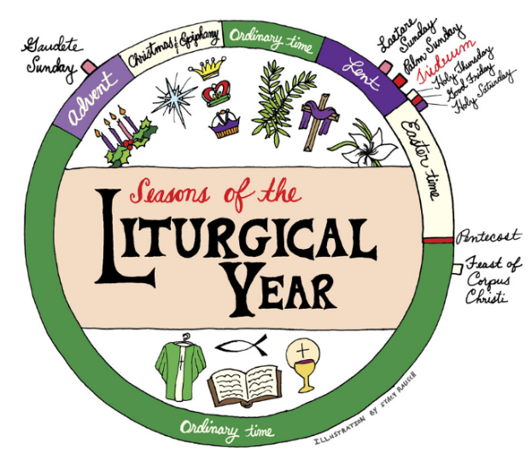


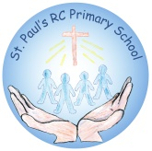

MISSION
‘Together in Faith, Working as One’
RE & Catholic Life Newsletter
RUDOLPH RUN
Wirral St John’s Hospice
Autumn 2nd Half Term 2025-2026
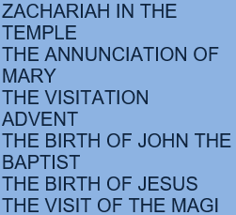


Y1&2
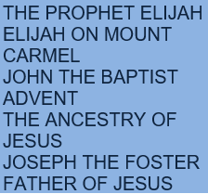


Y3&4
All Saints Day
Harvest
Remembrance Day
World Day of Prayer for the Poor
The Presentation of the Blessed Virgin Mary
Christ the King


Y5&6


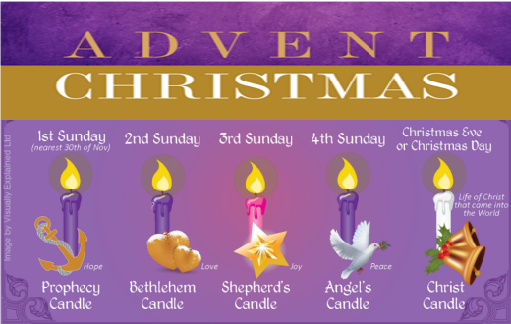


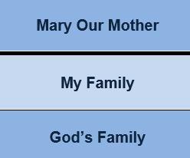
St Paul’s Prayer Requests

We should not bear our struggles on our own.
We, as a faith community, unite our prayers as an offering before Christ.
Feel free to share your prayer requests with us. We will add a ribbon to our prayer intentions wall and keep you in our thoughts and prayers.
Advent
FS/KS1 Nativity
KS2 Carol Concert
Christmastide

F2
F1
PS2

